**W1D3**

**QUESTION 1**

Divide And Conquer (DAC)

You are given an n x n integer 2d-array M[0 .. n – 1, 0 .. n – 1] with the following properties:

1. The number of rows is equal to the number of columns.
2. Each row is in nondecreasing order.
3. Each column is in nondecreasing order.

See the examples (M1, M2 and M3) below.

|  |  |  |  |  |
| --- | --- | --- | --- | --- |
| 5 | 6 | 7 | 8 | 9 |
| 10 | 11 | 12 | 13 | 14 |
| 15 | 16 | 17 | 18 | 19 |
| 20 | 21 | 22 | 23 | 24 |
| 25 | 26 | 27 | 28 | 29 |

|  |  |  |  |  |
| --- | --- | --- | --- | --- |
| 5 | 7 | 8 | 14 | 15 |
| 6 | 9 | 13 | 16 | 23 |
| 10 | 12 | 17 | 22 | 24 |
| 11 | 18 | 21 | 25 | 28 |
| 19 | 20 | 26 | 27 | 29 |

|  |  |  |  |  |
| --- | --- | --- | --- | --- |
| 5 | 10 | 15 | 20 | 25 |
| 6 | 11 | 16 | 21 | 26 |
| 7 | 12 | 17 | 22 | 27 |
| 8 | 13 | 18 | 23 | 28 |
| 9 | 14 | 19 | 24 | 29 |

Let us call such arrays “Sorted Square of order n” for the purpose of this question.

(a) Write three different algorithm to generate Sorted Squares (of order n for n > 0) of the type M1, M2 and M3.  
  
Algorithm 1

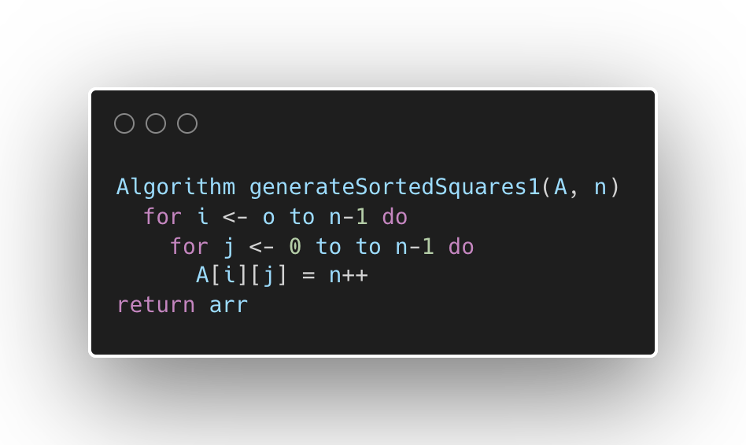

Algorithm 2

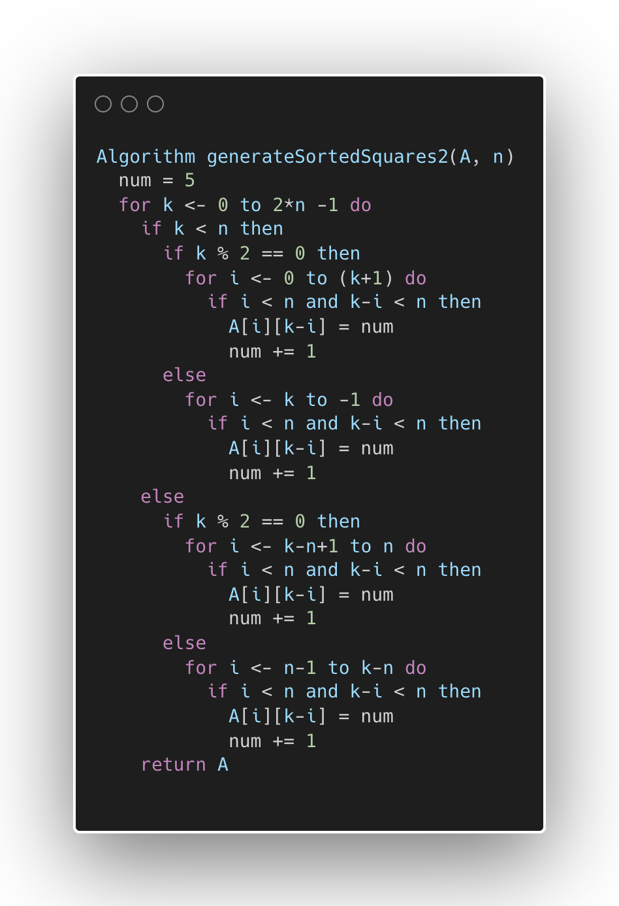

Algorithm 3

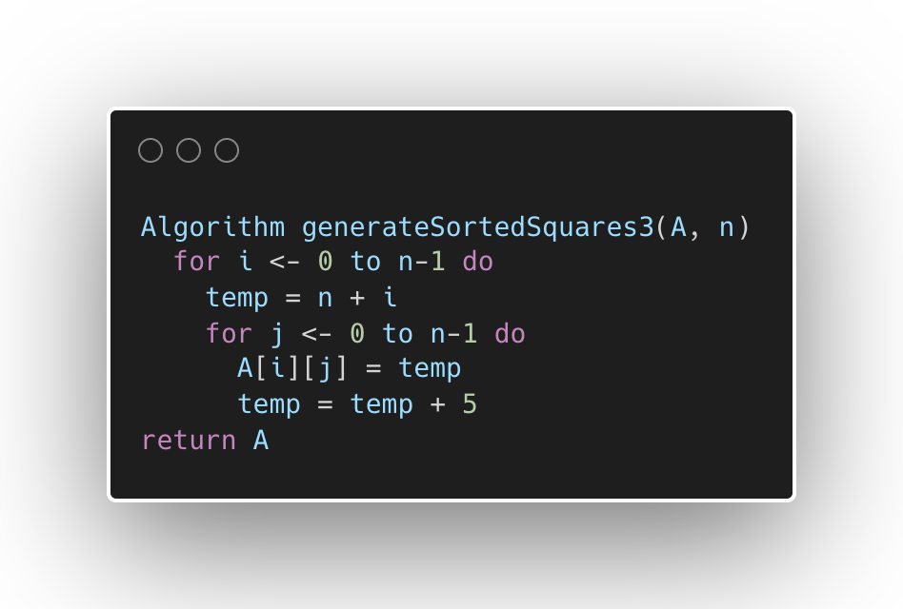

(b) Write a search algorithm *without DAC* “searchSS(M, key)” such that if key is present in the Sorted Square M, your algorithm will print both row and column numbers as a pair. If the key is not present in the Sorted Square M, it will print “Not Found”.

*Example: For the* Sorted Square *M2, if the key is 23, it will print (1, 4). However, if the key is 34, your algorithm will print “Not Found”.*

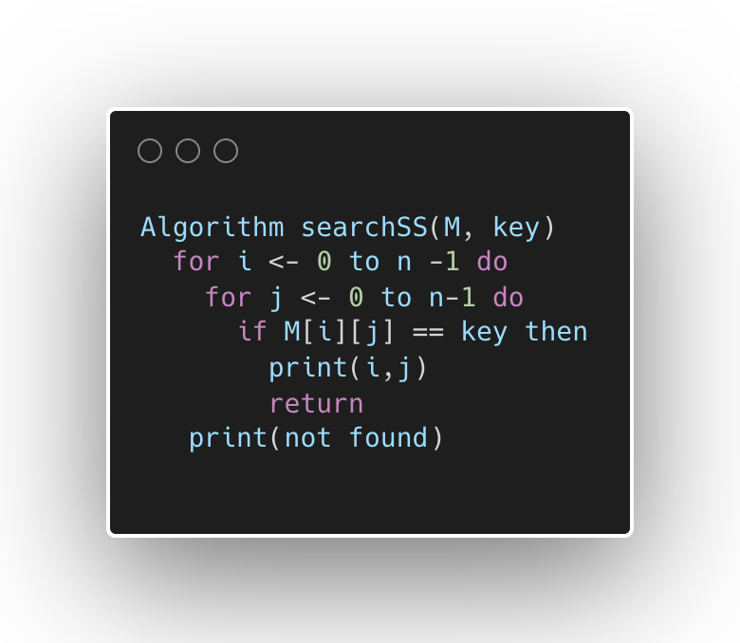

(b1) What is the time complexity of searchSS? Please explain your claim.

*O(n^2)*

We use two nested loop to iterates to search *key*

(b2) What is the space complexity of searchSS? Please explain your claim.

*O(1)*

The matrix M is provided as input and not copied or modified. No arrays, list, or other data structures are created that grow with the input.

(c) Write a search algorithm *with DAC* “DACsearchSS(M, key)” such that if key is present in the Sorted Square M, your algorithm will print both row and column numbers as a pair. If the key is not present in the Sorted Square M, it will print “Not Found”.

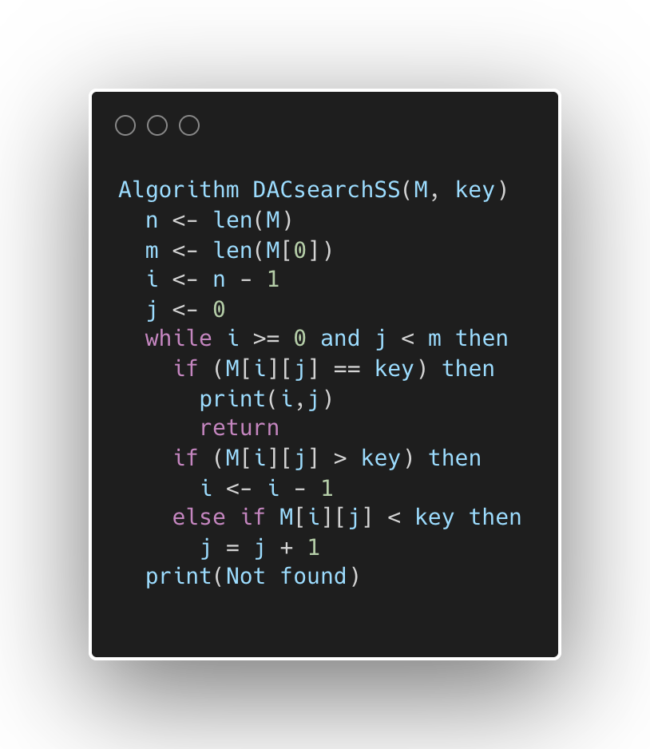

(c1) What is the time complexity of DACsearchSS? Please explain your claim.

O(m+n)

Each iteration either decrease i by 1 or increases j by 1. With bounds, i start at n-1 and can decrease at most n times, j start at 0 and can increase at most m times

(c2) What is the space complexity of DACsearchSS? Please explain your claim.

O(1)

Only 4 variables m, n, i, j. No array, list, or other data structures are created that grow with input.

(d1) Compare the algorithms searchSS and DACsearchSS using mathematical tools.

|  |  |  |  |
| --- | --- | --- | --- |
| Algorithm | Best case | Average case | Worst case |
| searchSS | O(1) | O(n^2) | O(n^2) |
| DACsearchSS | O(1) | O(m+n) | O(m+n) |

(d2) Compare the algorithms searchSS and DACsearchSS using empirical tools.

|  |  |  |  |  |  |
| --- | --- | --- | --- | --- | --- |
| Algorithm | N = 1000 | N = 2000 | N = 4000 | N = 8000 | N = 16000 |
| searchSS | 1ms | 2ms | 4ms | 7ms | 13ms |
| DACsearchSS | 3ms | 6ms | 14ms | 27ms | 58ms |

Write an extensive lab report outlining important concepts you learned through this example. In particular, comment of the appropriateness of DAC in this case.

**QUESTION 2**

Order them based on their complexity.

2^n , 2^(2n), 2^(n + 1), 2^( 2^n ) (Note: ^ stands for exponent operation. Example: 2^n = 2n )

|  |  |
| --- | --- |
| 2n | O(2n) |
| 2(n+1) | O(2*2n) |
| 2(2n) | O(22n) = O(4n) |
| 2(2^n) | O(22^n) |